Sound - 04
CLASS 09 - SCIENCE

 | Section A
1 | Match the columns and select the correct option from the codes given here. 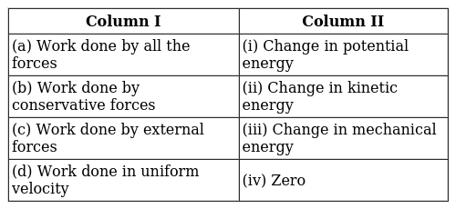  a) (a) - (ii), (b) - (i), (c) - (iii), (d) - (iv)  b) (a) - (iv), (b) - (ii), (c) - (i), (d) - (iii)  c) (a) - (iii), (b) - (iv), (c) - (ii), (d) - (i)  d) (a) - (i), (b) - (iii), (c) - (iv), (d) - (ii) | [1]
2 | Potential energy of an object at a height h is E$​_{p}$ = mgh. This equation is true only if  - The acceleration due to gravity is constant.  - The potential energy is path dependent.  a) Only (ii) is true.  b) Both (i) and (ii) are false.  c) Only (i) is true.  d) Both (i) and (ii) are true. | [1]
3 | If the force is applied at an angle$θ$ then work done is:  a) W = FS Tan$θ$ and W = work  b) W = FS$θ$ and S = Distance  c) W = FS Cos$θ$ and F = Force  d) W = FS Sin$θ$ and W = work | [1]
4 | In a collision:  a) the momentum of the system is constant  b) momentum is always transferred  c) momentum is always lost  d) energy is lost always | [1]
5 | One joule work is said to be done when:  a) a force of 1 N displaces a body by 1 cm  b) a force of 1 dyne displaces a body by 1 m  c) a force of 1 N displaces a body by 1 m  d) a force of 1 dyne displaces a body by 1 cm | [1]
6 | In an oscillating simple pendulum:  a) Only energy transformation takes place  b) Work is done by the force of gravity  c) Work is done by the mass  d) Work is done by the string | [1]
7 | The value of one kWh is:  a) 300 joule  b) 3.6$×$ 10 $​^{6}$ joule  c) 3.6$×$ 10 $​^{3}$ Joule  d) 3.6$×$ 10 $​^{8}$ Joule | [1]
8 | The work done by a force on a body will be positive if the:  a) body moves perpendicular to the direction of motion  b) body moves opposite to the direction of the applied force  c) the body moves along the direction of the applied force  d) body does not move | [1]
9 | The diagram shows an object released from point X and travelling on a frictionless track. If a heavier object is taken in consideration then 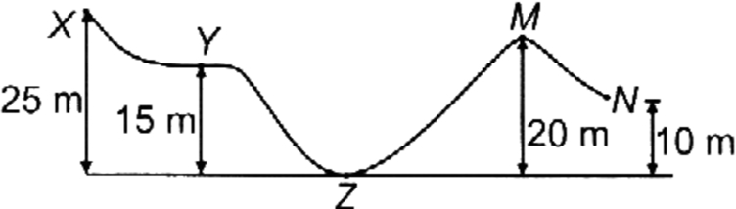  - It will move with a greater speed at Y.  - The speed of the object at M is 10 m s$​^{−1}$ .  a) Neither (i) nor (ii) is true.  b) Only (i) is true.  c) Both (i) and (ii) are true.  d) Only (ii) is true. | [1]
10 | An electric bulb of 60 W burns for 5 hours a day. The cost of electricity involved in a month of 30 days at$₹$ 3.00 per unit is (in $₹$ )  a) 2.70  b) 2700  c) 270  d) 27 | [1]
11 | A truck and a car having equal kinetic energies are stopped by applying equal retarding force. If S$​_{1}$ and S $​_{2}$ are the distances covered by truck and car respectively, before stopping, then  a) S$​_{1}$ < S $​_{2}$  b) S$​_{1}$ = S $​_{2}$  c) Cannot say  d) S$​_{1}$ > S $​_{2}$ | [1]
12 | A tank contains water of mass ’m’ to a height ’h’. The potential energy associated is  a) Zero  b) mgh  c) mg$\frac{h}{2}$  d) Depends on the radius of the tank | [1]
13 | Which of the following quantities have the same units?  a) Power and energy  b) Work and force  c) Power and work  d) Work and energy | [1]
14 | A skier of mass 50 kg stands at point P at the top of the ski jump and moves from P to Q and takes off his jump at Q as shown in figure. If 50% of the change in the gravitational potential energy of the skier between points P and Q becomes the kinetic energy at Q, then the speed at which the skier arrives at Q is 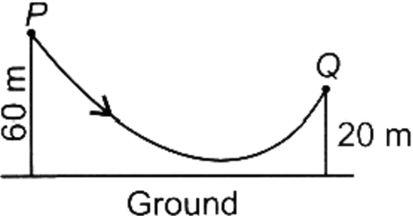  a) 10m s$​^{−1}$  b) 20m s$​^{−1}$  c) 40m s$​^{−1}$  d) 30m s$​^{−1}$ | [1]
15 | When a body falls freely towards the earth, then its total energy  a) Increases  b) Decreases  c) Remains constant  d) First increases and then decreases | [1]
16 | One horsepower is equal to:  a) 746 W  b) 1000 W  c) 500 W  d) 764 W | [1]
17 | No work is done when:  a) textbook is lowered diagonally at a constant velocity  b) there is no component of force, parallel to the direction of motion  c) a box is pushed along horizontal floor  d) a nail is hammered into a wooden box | [1]
18 | A horse exerts a force of 200N to pull the cart. If the horse - cart system moves with velocity 36km/h on the level road., then find the power of the horse in terms of horsepower (1hp = 746W).  a) 2.5 h.p.  b) 3.68 h.p  c) 2.68 h.p  d) 1.68 h.p | [1]
19 | Statement 1 : Potential energy of a stretched or compressed spring is directly proportional to square of extension or compression. Statement 2 : Graph between potential energy of a spring versus the extension or compression of the spring is a straight line.  a) Both statement 1 and statement 2 are true but statement 2 is not the correct explanation of statement 1.  b) Statement 1 is true but statement 2 is false  c) Both statement 1 and statement 2 are false.  d) Both statement 1 and statement 2 are true and statement 2 is the correct explanation of statement 1. | [1]
20 | Kilowatt hour is a unit of ________.  a) mass  b) power  c) energy  d) joule | [1]
21 | If a force of F newton moves a body with constant speed v, the power delivered by it is:  a) $\frac{F}{V}$  b) F$​^{2}$ v  c) Fv  d) $\frac{V}{F}$ | [1]
22 | A mass of M kg is suspended by a weightless string. The horizontal force that is required to displace it until the string making an angle of 45° with the initial vertical direction is  a) $Mg\left(\sqrt{2}+1\right)$  b) $Mg\sqrt{2}$  c) $Mg\left(\sqrt{2}−1\right)$  d) $\frac{Mg}{\sqrt{2}}$ | [1]
23 | The SI unit of energy is ________.  a) joule  b) volume  c) power  d) motion | [1]
24 | Two inclined frictionless tracks, one gradual and the other steep meet at point A from where two stones (I and II) are allowed to slide down from rest, one on each track as shown in figure. Which of the following statements is correct? 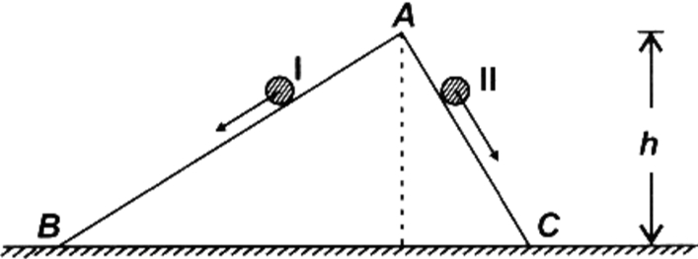  a) Both the stones reach the bottom at the same time but not with the same speed.  b) Both the stones reach the bottom with the same speed and stone II reaches the bottom earlier than stone I.  c) Both the stones reach the bottom at different times and with different speeds.  d) Both the stones reach the bottom with the same speed and stone I reaches the bottom earlier than stone II. | [1]
25 | If a body is stored at a height h then it will possess:  a) Both potential and kinetic energy  b) Potential energy  c) Kinetic energy  d) Work | [1]
26 | An elevator with load, weighting 500 kg is moving up with a velocity of 0.2 ms$​^{−1}$ . The power of the motor in horsepower is: (1 H.P. = 746 watt)  a) 1  b) 1.5  c) 1.3  d) 1.2 | [1]
27 | A graph of the total energy of a freely falling body from a height is  a) 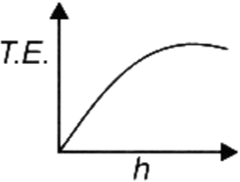  b) 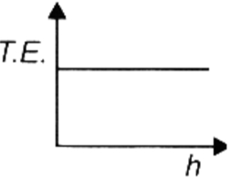  c) 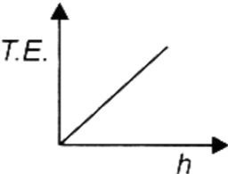  d) 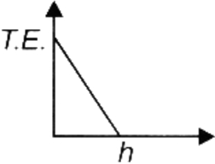 | [1]
28 | S.I. unit of power is ________.  a) J/s  b) s/J  c) Js  d) Js$​^{2}$ | [1]
29 | If the body starts from rest, then change in its kinetic energy is:  a) Positive  b) May be Positive or negative depending upon the mass of the body  c) Negative  d) Zero | [1]
30 | A cylinder and a cone having radius r$​_{1}$ and r $​_{2}$ respectively (r $​_{1}$ > r $​_{2}$ ) are having the same mass. Then pressure exerted by the cylinder is:  a) greater than cone  b) equal to cuboid  c) equal to cone  d) less than cone | [1]
31 | A boy throws a ball vertically upwards. As the ball rises its total energy (neglect friction):  a) increases  b) decreases  c) zero  d) remains the same | [1]
32 | If 1 newton of force displaces a body by 1 m, the work done is:  a) 10 joule  b) 5 joule  c) Depends on time  d) 1 joule | [1]
33 | An object of mass 5 kg falls from a height of 5 m above the ground. The loss of potential energy of the mass is:  a) 245 J  b) 25 J  c) 50 J  d) 2.5 kJ | [1]
34 | A man holds and displaces a 20 kg mass horizontally in his stretched hand:  a) He does 200 joules of work per metre  b) He does zero work against the force of gravity  c) The work done against gravity is equal to the muscular energy  d) The work done against gravity cannot be estimated but non - zero. | [1]
35 | A body at rest may have:  a) momentum  b) potential energy  c) velocity  d) kinetic energy | [1]
36 | If the bulbs of 60 W and 40 W are connected in series to a 220 V source the bulb which glows brighter is:  a) 60 W  b) Depends on the make of the bulb  c) Both glow equally bright  d) 40 W | [1]
37 | In doing the experiment, a student puts the solid iron cuboid in an upright position on loose sand. After that, he has laid it. In these two cases:  a) the effect of thrust on sand is smaller while in an upright position than lying.  b) effects of the thrust are same but different thrusts are there  c) thrust is the same and its effects are also the same  d) thrust is same but effects are different | [1]
38 | Weight lifter lifts 240 kg from the ground to a height of 2.5 m in 3 seconds. His average power is:  a) 1960 W  b) 196 W  c) 1.96 MW  d) 19.6 kW | [1]
39 | A body is falling from a height h. After it has fallen a height$\frac{h}{2}$ . it will possess  a) only potential energy  b) more kinetic and less potential energy  c) only kinetic energy  d) half potential and half kinetic energy | [1]
40 | One unit of electricity is consumed by A : P = 40 W bulb used for t = 25 hoursB : P = 20 W bulb used for t = 50 hours Both A and B are true as energy E in kWh is best related as  a) E = Pt  b) $E= \frac{t}{1000}$  c) $E= \frac{pt}{1000}$  d) $E= \frac{p}{100}$ | [1]
41 | Which one of the following is not the unit of energy?  a) Joule  b) Kilowatt hour  c) Kilowatt  d) Newton metre | [1]
42 | Which of the following statements is true for the pressure exerted by a solid body?  a) Greater the area over which the force acts, greater is the pressure  b) It does not depends upon the area of contact for the magnitude of force  c) It depends upon the area of contact for the same magnitude of the force:  d) It does not depend upon the area of contact for the same magnitude of force | [1]
43 | When the speed of a moving object is doubled, its:  a) kinetic energy increases 4 times  b) kinetic energy is doubled  c) acceleration is doubled  d) weight is doubled | [1]
44 | Two masses m and 2m are dropped from a certain height ’h’. Then on reaching the ground,  a) K.E. of the lighter is 4 times the K.E. of the heavier  b) K.E. of the heavier is 4 times the K.E. of the lighter  c) K.E. of the heavier is more than that of the lighter.  d) K.E. of them will be equal | [1]
45 | A girl is carrying a school bag of 3 kg mass on her back and moves 200 m on a leveled road. The work done against the gravitational force will be (g = 10m/s$​^{2}$ )  a) 6 J  b) 0.6 J  c) Zero  d) 6 × 10$​^{−3}$ J | [1]
46 | A rickshaw puller pulls the rickshaw by applying a force of 100 N. If the rickshaw moves with a constant velocity of 36 km/h. Find the power of rickshaw puller.  a) 10 Watt  b) 100 Watt  c) 2000 Watt  d) 1000w | [1]
47 | Water stored in a dam possess  a) Potential energy  b) No energy  c) Electrical energy  d) Kinetic energy | [1]
48 | Two discs of the same radii and the same mass are resting over one another co - axially on the sand. If one disc is removed gently, then the pressure exerted by the single - disc will be:  a) doubled  b) remains the same  c) half  d) can’t be predicted | [1]
49 | A body of mass 2 kg is thrown up vertically with a kinetic energy of 490 J. If the acceleration due to gravity is 9.8 m s$​^{−2}$ , the height at which the kinetic energy of the body becomes half of the original value is  a) 10 m  b) 50 m  c) 12.5 m  d) 25 m | [1]
50 | Coolie A takes 1 min to raise a box of mass m through a height of 2.0 m. Another coolie B takes 30 s for the same job. Which one has greater power?  a) Both Coolie A andCoolie B  b) Coolie B  c) Cannot say  d) Coolie A | [1]
51 | A ball dropped from a height of 10m. if the energy of the ball reduces by 40% after striking the ground, how much high can the bounce back? (g = 10m/s$​^{2}$ )  a) 6 m  b) 5 m  c) 0 m  d) 3 m | [1]
52 | A boy of mass 50 kg runs up a staircase of 45 steps in 9 s. If the height of each step is 15 cm, find his power. Take g = 10 ms$​^{–2}$ .  a) 400 W  b) 560 W  c) 270 W  d) 375 W | [1]
53 | A boy of mass 50 kg runs up a flight of 120 stairs, each measuring a height of 25 cm, in one minute and 40 seconds. If g = 10 m s$​^{−2}$ , the power of the boy is  a) 250 W  b) 750 W  c) 150 W  d) 500 W | [1]
54 | A truck of mass 800 kg generates a power of 20000 W. How much time does the truck need to accelerate from a speed of 20 m s$​^{−1}$ to 30 m s $​^{−1}$ ?  a) 10 s  b) 7.5 s  c) 5 s  d) 6.3 s | [1]
55 | When a body is whirled in a circle the work done by the centripetal force is:  a) negative  b) zero  c) positive  d) infinite | [1]
56 | On tripling the speed of motion of a body, the change in K.E. is:  a) 8 times  b) 2 times  c) 9 times  d) 4 times | [1]
57 | To observe and compare the pressure exerted by solid iron cuboid on the sand, a student takes a cuboid of 5 kg and has a dimension of its base 30 cm ×15 cm and measures its pressure, then he mounts the cuboid on a cylinder having a radius of base 7 cm and weight equal to 1 kg. The pressure of the whole set - up on the sand is:  a) decreased by 3.5 times  b) remains same  c) can’t say  d) increased by 3.5 times | [1]
58 | The cgs. unit of work is:  a) watt  b) joule  c) dyne  d) erg | [1]
59 | The heart does 1.5 J of work in each heartbeat. How many times per minute does it beat if its power is 2watt?  a) 80 times  b) 60 times  c) 8 times  d) 10 times | [1]
60 | The potential energy of a person is minimum when:  a) a person is sitting in a chair  b) a person is sitting on the ground  c) a person is lying on the ground  d) person is standing | [1]
61 | A body moves under a variable force. For the body a plot of velocity versus time is shown in figure. The correct statement is 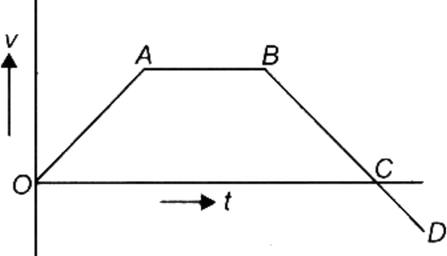  a) In moving from B to C, work done by the force on the body is positive  b) In moving from A to B, the body does work on the system  c) In moving from O to A, work done by the force on the body is negative  d) In moving from C to D, work done by the force on the body is positive | [1]
62 | An object of mass 1 kg has a potential energy of 1 joule relative to the ground when it is at a height of:  a) 1 m  b) 32 m  c) 9.8 m  d) 0.102 m | [1]
63 | An iron sphere of mass 30 kg has the same diameter as an aluminum sphere whose mass is 10.5 kg. The spheres are dropped simultaneously from a cliff. When they are 10 m from the ground, they have the same.  a) kinetic energy  b) potential energy  c) acceleration  d) momentum | [1]
64 | Statement 1: A man carrying a bucket of water and walking on a rough level road with a uniform velocity does no work while carrying the bucket. Statement 2: The work done on a body by a force (F) in giving it a displacement (S) is defined as W $=\vec{F}⋅\vec{S}=FScosθ,$ where $θ$ is the angle between vectors $\vec{F}$ and $\vec{S}$ .  a) Statement 1 is true but statement 2 is false.  b) Both statements 1 and 2 are true and statement 2 is the correct explanation of statement 1.  c) Both statements 1 and 2 are false.  d) Both statements 1 and 2 are true but statement 2 is not the correct explanation of statement 1. | [1]
65 | A mass m is moving in a circle of radius 1 m with a uniform speed of 5 m/s. The work done when its radius turns by 60$​^{o}$ is:  a) zero  b) 10 joule  c) 2.5 joule  d) 5 joule | [1]
66 | Statement 1 : If a light body and a heavy body possess the same momentum, the lighter body will possess more kinetic energy. Statement 2 : The kinetic energy of a body varies as the square of its velocity.  a) Both statements 1 and 2 are true and statement 2 is the correct explanation of statement 1.  b) Both statements 1 and 2 are true but statement 2 is not the correct explanation of statement 1.  c) Both statements 1 and 2 are false.  d) Statement 1 is true but statement 2 is false. | [1]
67 | Calculate the potential energy of a person having 60 kg mass on the summit of Mt. Everest. Height of Mt. Everest is 8848 m from sea level. (g = 9.8 m/s$​^{2}$ ).  a) 52,02,624 joule  b) 25 joule  c) 19.7 joule  d) 2,02,624 Joule | [1]
68 | In case of negative work the angle between the force and displacement is:  a) 180$​^{o}$  b) 90$​^{o}$  c) 0$​^{o}$  d) 45$​^{o}$ | [1]
69 | ________is the SI unit of work.  a) joule  b) energy  c) work  d) mass | [1]
70 | If the force applied on the body distances the body in the opposite direction of force applied then work done is:  a) Negative  b) Positive  c) Constant  d) Zero | [1]
71 | A total of 4900 J was spent in lifting a mass of 50 kg. the mass was raised to a height of:  a) 10 m  b) 245,000 m  c) 960 m  d) 98 m | [1]
72 | In the explosion of a cracker/bomb:  a) momentum is conserved  b) energy is produced  c) momentum remains unconserved  d) internal energy is absorbed | [1]
73 | To observe and compare the pressure exerted by solid iron cuboid, a student marked all the faces of cuboid from 1 to 6. After doing the experiment with all faces of cuboid, he observed that  a) adjacent faces of cuboid exerted the same pressure  b) all the faces of cuboid exerted same pressure on the sand  c) opposite parallel faces of cuboid exerted unequal pressure on the sand  d) opposite parallel faces of the cuboid exerted some pressure on the sand | [1]
74 | A microphone converts sound energy to:  a) A pulse  b) Sound energy  c) Electrical signal/energy  d) A wave | [1]
75 | The potential energy of a body is by virtue of its ________.  a) direction  b) power  c) position  d) energy | [1]

